Department of Computer Science and Engineering (Cyber Security)
Faculty Profile

Name | Mrs. B. Neelu |  |  | 
Designation | Assistant Professor/HoD
Qualifications | M.E.,(Ph.D)
Department | Computer Science and Engineering(Cyber Security)
AICTE Code | 1-2708861079
Anna University  Faculty Code | 6118372
Area of Specialization | Design and Analysis of Algorithm, Theory of Computation and Compiler  Design.
Date of Joining (PSVCET) | 29-06-2018
Date of Birth & Age | 10.02.1990 & 34
Experience in (Years) | Teaching | 13 | Industry |  | Nil
Number of Papers  Published | National  Journals | 6 | International  Journals |  | Nil
Number of Papers  Presented | National  Conferences | 12 | International  Conferences |  | 05
Number of FDP Attended | Offline | 02 | Online |  | 16
Books Published | Nil
Patents | Granted | Nil | Published |  | Nil
Grants Received: | Nil
Contact Details | Email: | hodcsecs@psvcet.ac.in,  neelu_cse@psvcet.ac.in
Contact Details | Mobile | 6380807627
Addition Information (if any) | - Successfully completed 1 NPTEL course  - Acted as chief guest for the technical seminar on compiler design

Department of Computer Science and Engineering(Cyber Security)
Faculty Profile

Name | Mrs. K.R.BUVANA |  |  | 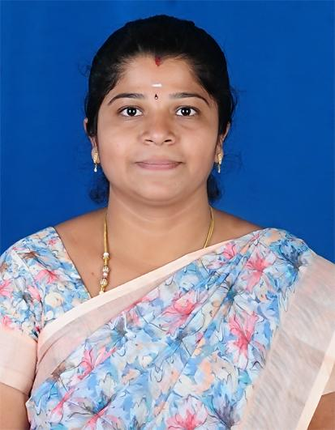
Designation | Assistant Professor
Qualifications | M.E.,
Department | Computer Science and Engineering(Cyber Security)
AICTE Code | 1-9468341250
Anna University  Faculty Code | 6118373
Area of Specialization | C , Python, Java Programming, Full Stack Web Development, Visual Effects, Cyber Security
Date of Joining (PSVCET) | 07-07-2025
Date of Birth & Age | 15-09-1989 & 35
Experience in (Years) | Teaching | 5 | Industry |  | Nil
Number of Papers  Published | National  Journals | Nil | International  Journals |  | Nil
Number of Papers  Presented | National  Conferences | Nil | International  Conferences |  | 01
Number of FDP Attended | Offline | 01 | Online |  | 08
Books Published | Nil
Patents | Granted | Nil | Published |  | Nil
Grants Received: | Nil
Contact Details | Email: | buvanakr3@gmail.com
Contact Details | Mobile | 9952122543
Addition Information (if any)

Department of Computer Science and Engineering (Cyber Security)
Faculty Profile

Name | Mrs. K.Pavithra |  |  | 
Designation | Assistant Professor
Qualifications | M.E.,
Department | Computer Science and Engineering (Cyber Security)
AICTE Code | 1-9314030079
Anna University  Faculty Code | 6118374
Area of Specialization | Python, C, Java Programming, Artificial Intelligence and Machine Learning, Data structures, Cyber security, Computer Network
ate of Joining (PSVCET) | 07-07-2025
Date of Birth & Age | 04-06-1987 & 37
Experience in (Years) | Teaching | 7 | Industry |  | Nil
Number of Papers  Published | National  Journals | 1 | International  Journals |  | -
Number of Papers  Presented | National  Conferences | - | International  Conferences |  | 1
Number of FDP Attended | Offline | 02 | Online |  | 12
Books Published | Nil
Patents | Granted | Nil | Published |  | Nil
Grants Received: | Nil
Contact Details | Email: | pavivinnarasan@gmail.com
Contact Details | Mobile | 9003458958
Addition Information (if any)

