Department of Information Technology Faculty Profile

Name | S.Kanimozhi |  |  | 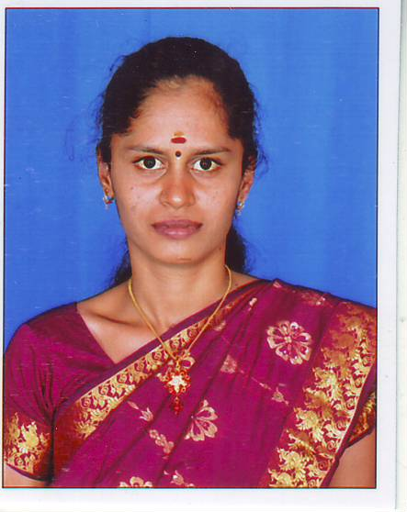
Designation | Assistant Professor
Qualifications | M.Tech
Department | Information Technology
AICTE Code | 2701360236
Anna University Faculty Code | 5118114
Area of Specialization | CSE
Date of Joining (PSVCET) | 02.07.2024
Date of Birth & Age | 02.11.1987
Experience in (Years) | Teaching | 7 Yrs | Industry |  | Nil
Number of Papers  Published | National  Journals | - | International  Journals |  | 1
Number of Papers  Presented | National  Conferences | - | International  Conferences |  | 1
Number of FDP Attended | Offline | - | Online |  | 2
Books Published | 5
Patents | Granted | Nil | Published |  | Nil
Grants Received: | -
Contact Details | Email: | kani.gopika@gmail.com
 | Mobile | 8667273233
Addition Information  (if any) | -

