Department of Information Technology
Faculty Profile

Name | Miss.M.K.Priyadharshini |  |  | 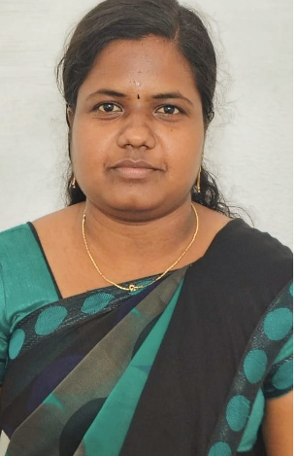
Designation | Assistant Professor
Qualifications | M.E
Department | Information Technology
AICTE Code
Anna University Faculty Code
Area of Specialization | Computer Science and Engineering
Date of Joining (PSVCET) | 12.08.2024
Date of Birth& Age | 28.08.1995- 28 yrs
Experience in (Years) | Teaching | 2 | Industry |  | -
Number of Papers  Published | National  Journals | 0 | International  Journals |  | 0
Number of Papers  Presented | National  Conferences | 2 | International  Conferences |  | 0
Number of FDP Attended | Offline | 1 | Online |  | 1
Books Published | Nil
Patents | Granted | Nil | Published |  | Nil
Grants Received: | Nil
Contact Details | Email: | krishpriya2895@gmail.com
 | Mobile | 9047856136
Addition Information
(if any)

